# SNF

**Task:** Optimize all 5 parameters: {At, Ka, alpha, Km, beta_max}

**Criteria:**

1. Relative amp of Ptot > 0.25

2. max(Ptot) is minimized s.t Kd is maximized

**Method**: simulated annealing with fmincon for the final step; Options: {'TemperatureFcn','temperatureboltz', 'AnnealingFcn','annealingboltz'}

**Cost function:**

**Range of search:**

**Initial guesses:**

100 random samples with Latin hypercube in the range above for the logarithm values of the parameters.

**Results:**

**100 runs:**

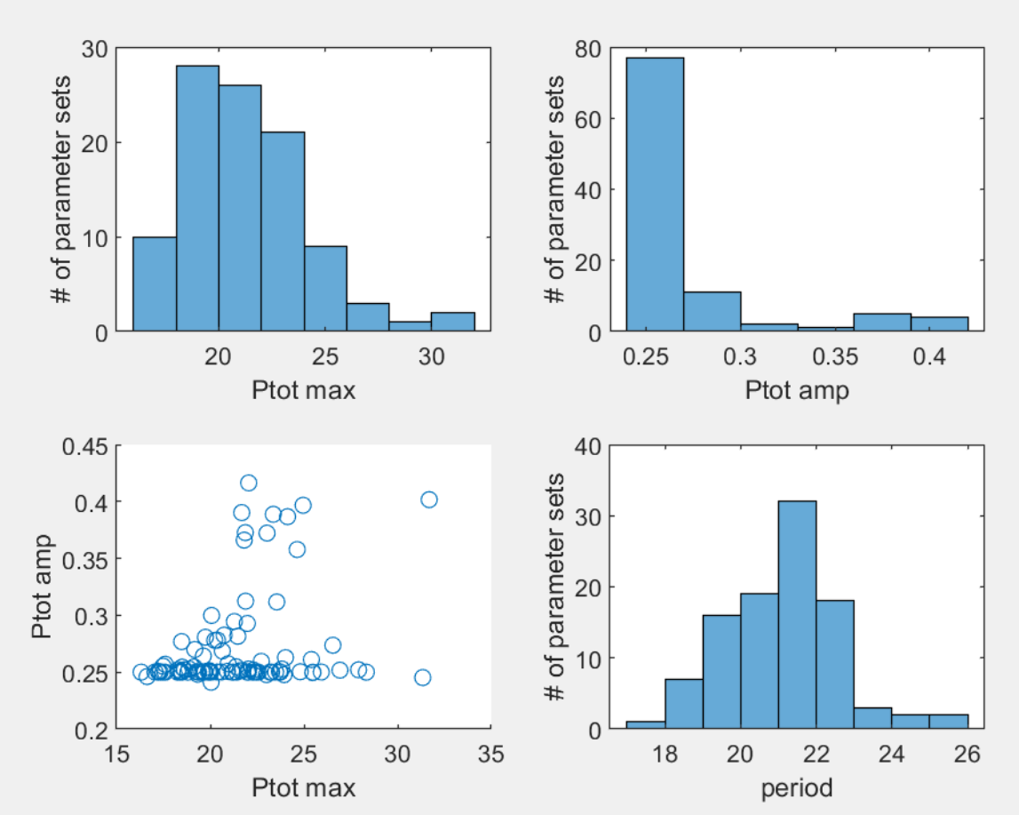

**1093 runs:**

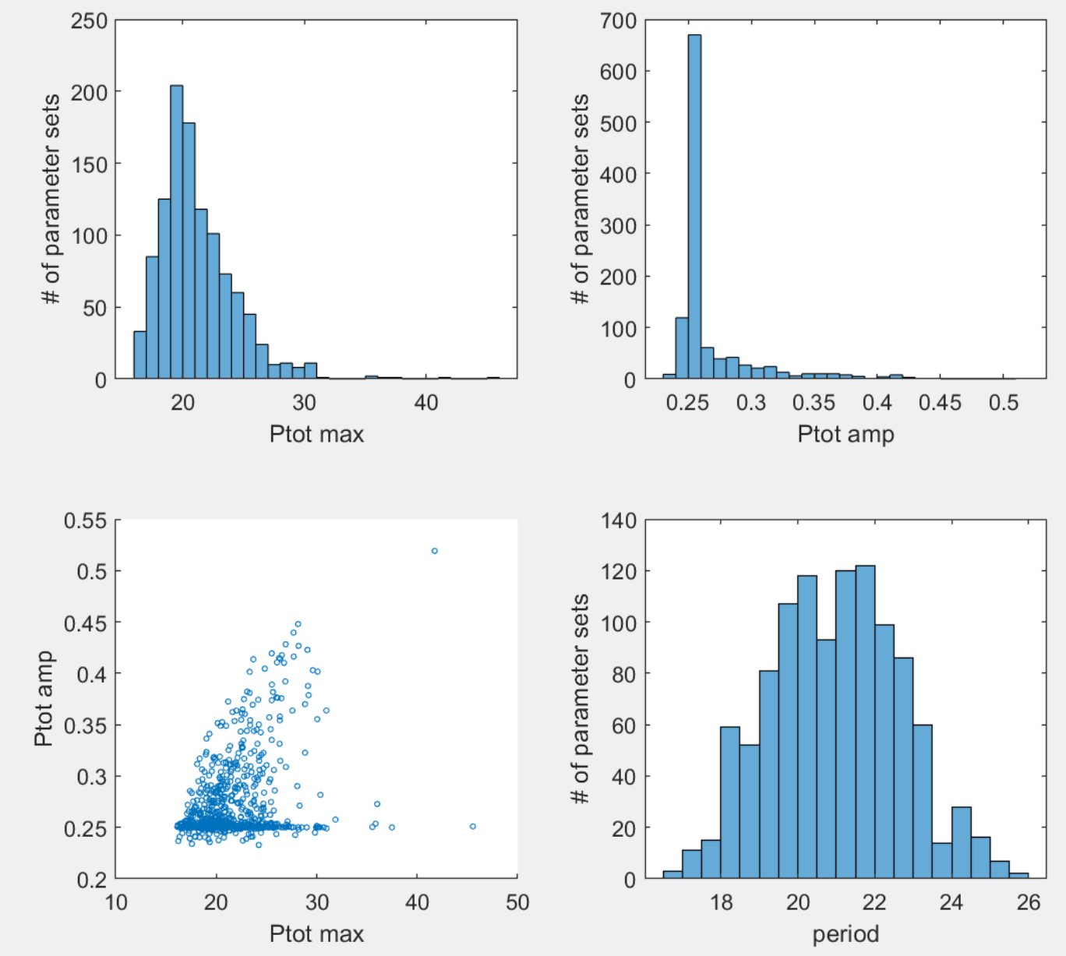

**Best set (with lowest max(Ptot))**

**Out of 100 runs:**

[At, KA, alpha, Km, beta_max] = [2.7290 95.7827 145.9987 1.0268 2.1202];

period_sim: 21.7500

Ptot_max_sim: 16.3082

Ptot_amp_sim: 0.2500

**Out of 1093 runs:**

[At, KA, alpha, Km, beta_max] = [2.0189 1.0639 6.7443 1.0719 2.1384];

period_sim: 21.5556

Ptot_max_sim: 16.1270

Ptot_amp_sim: 0.2505

**Patterns for the top parameter sets**

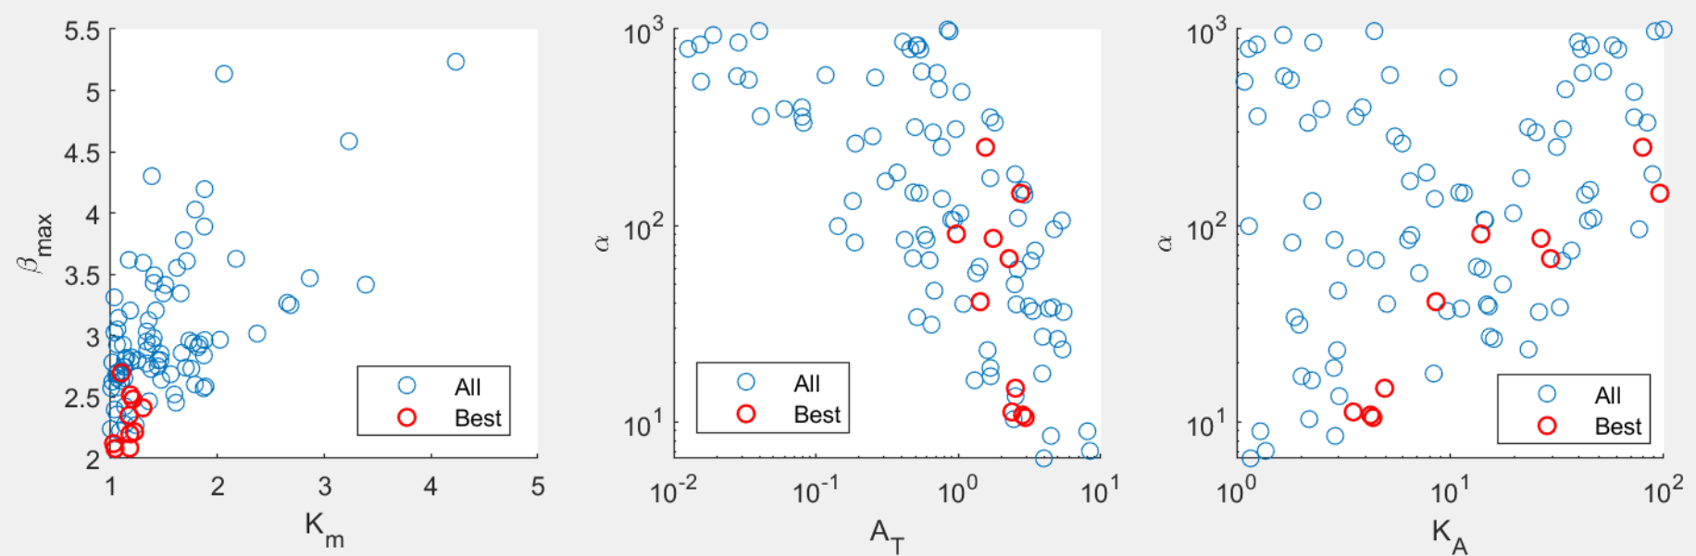

Blue: all 100 sets from optimization. Red: 10 sets with lowest max(Ptot).

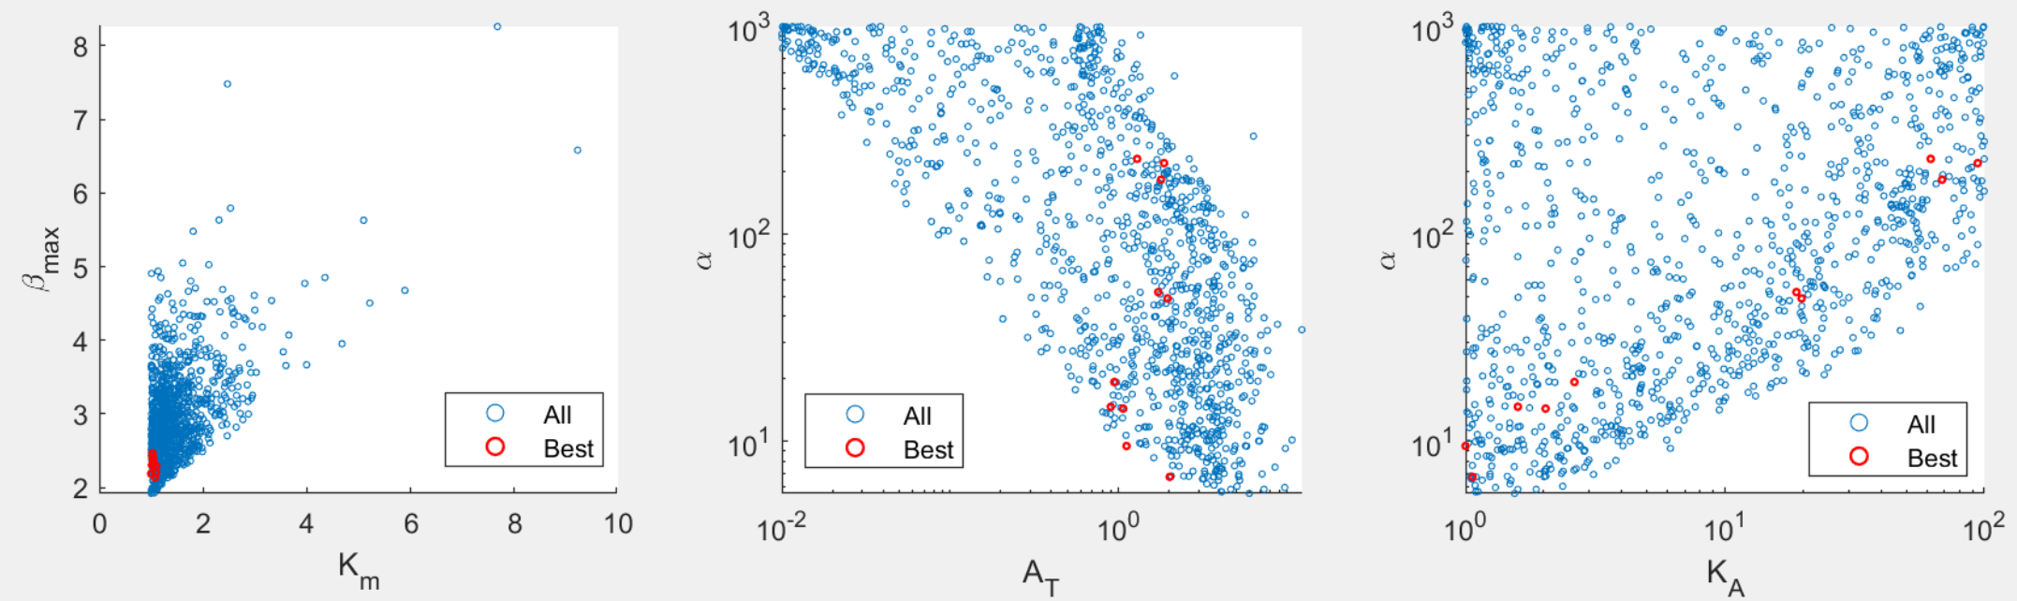

Blue: all 1093 sets from optimization. Red: 10 sets with lowest max(Ptot).

Main patterns:

1. Lower Km and beta_max are preferred, which is not surprising, as lower values in both parameters slow down PER degradation and introduce time delay.
2. Alpha and AT are negatively correlated. This result is opposite to the trend in L models, although this comparison is not done between the same type of diagrams.
3. Alpha and KA positively correlated.
4. Period strongly correlated with beta_max (figure below). This is not surprising, as beta_max determines the time delay.

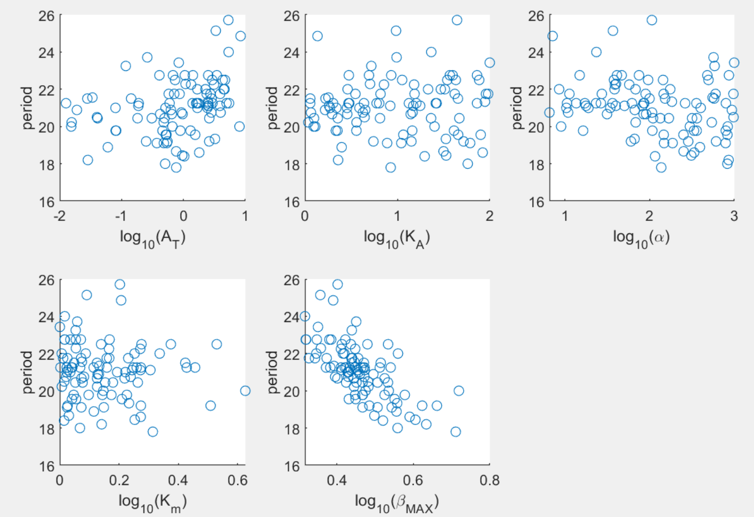

100 runs

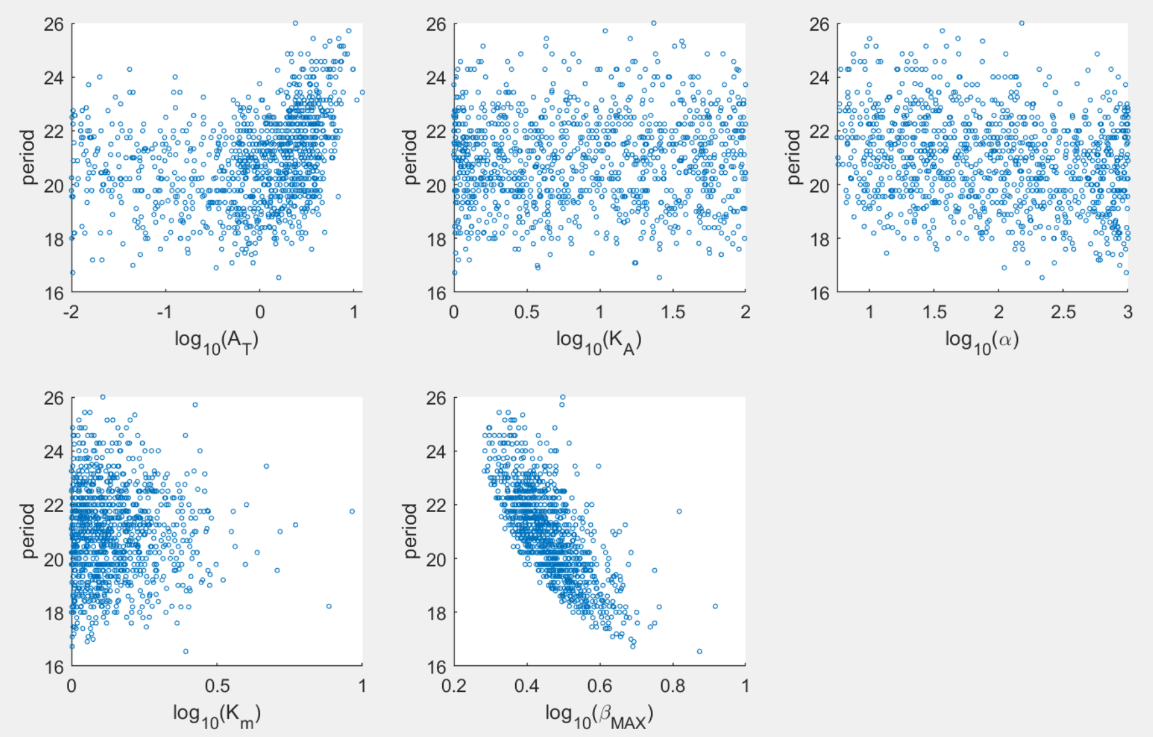

1093 runs

# NNF

**Task:** Optimize all 7 parameters: {delta, Amax, Vmax, Ka, alpha, Km, beta_max}

**Criteria:**

1. Relative amp of Ptot > 0.25

2. max(Ptot) is minimized s.t Kd is maximized

~~3. BMAL (At) average level matches SNF model~~

4. Relative amp of BMAL > 0.2

~~5. Period of Ptot matches SNF~~

6. max(Rev) < 10

**Method**: simulated annealing with fmincon for the final step; Options: {'TemperatureFcn','temperatureboltz', 'AnnealingFcn','annealingboltz'}

**Cost function:**

**Range of search:**

**Initial guesses:**

100 random samples with Latin hypercube in the range above for the logarithm values of the parameters.

**Results:**

100 runs:

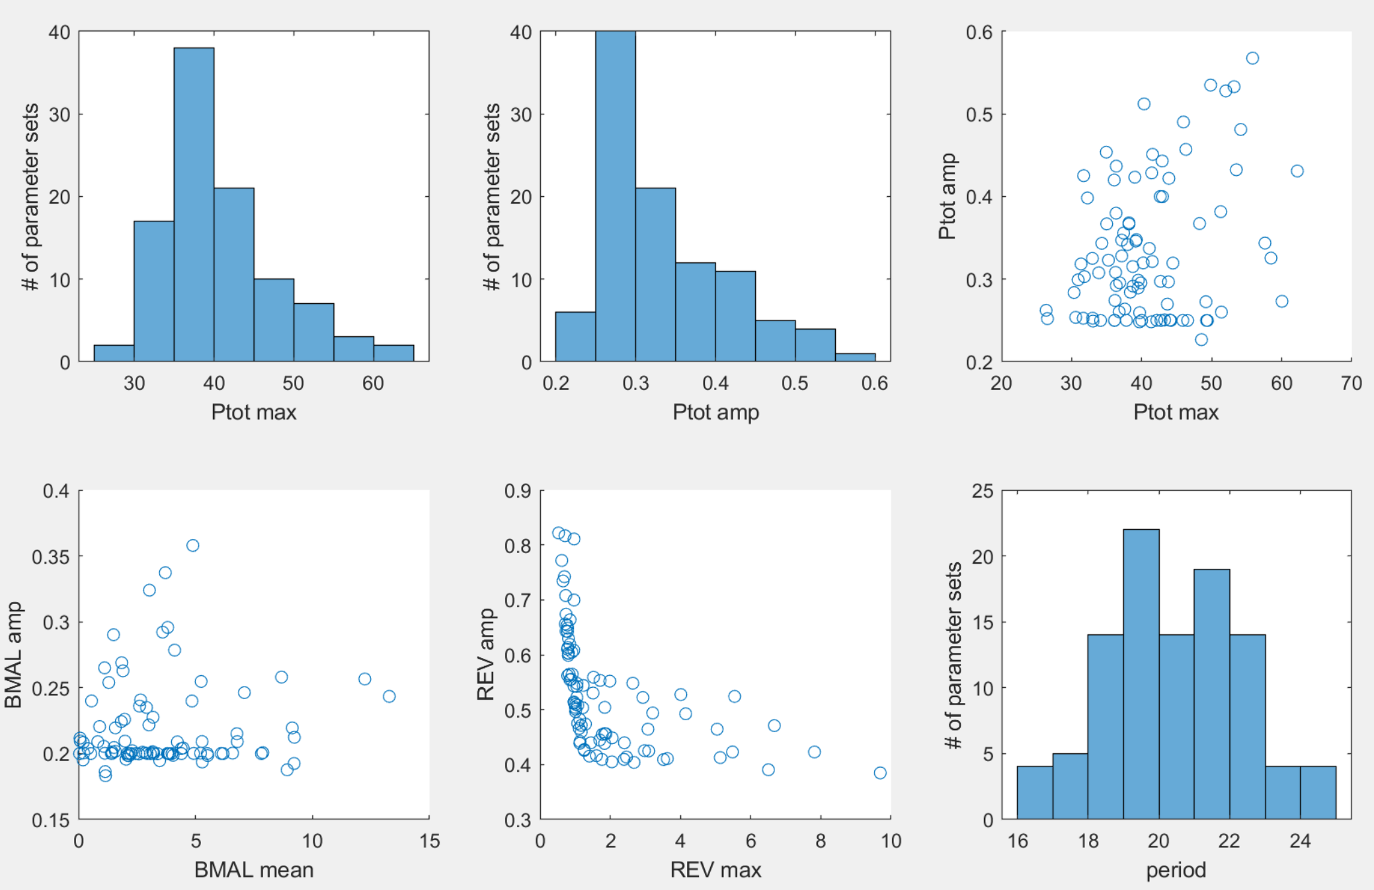

NNF requires a moderately larger Ptot_max, and decreases dimensional Kd? (may need to run more times to confirm?)

1085 run:

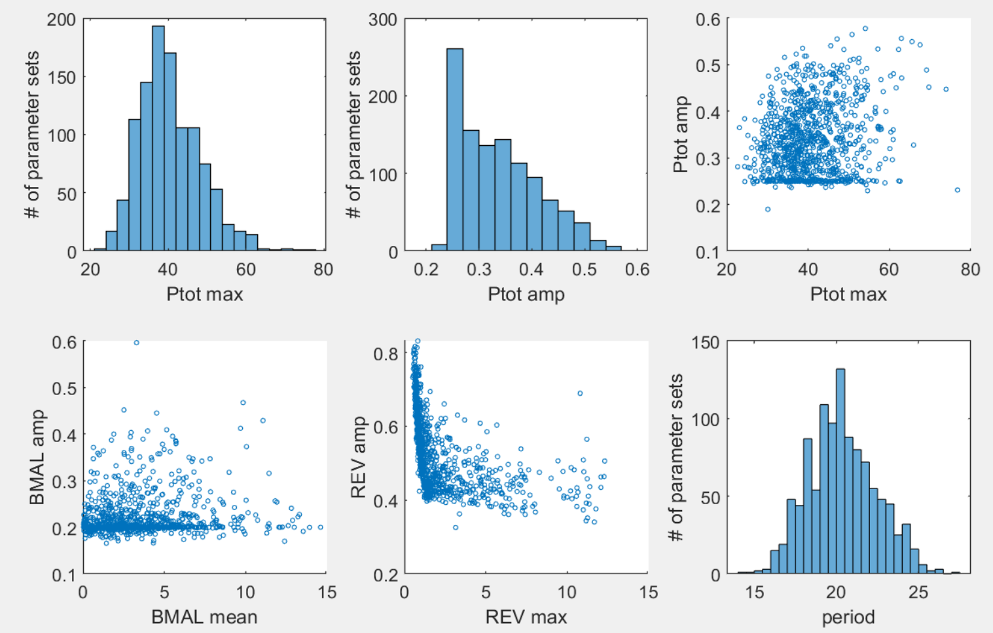

**Best set (with lowest max(Ptot))**

**Out of 100 runs:**

[delta, Amax, Vmax, Ka, alpha, Km, beta_max] = [25.3886 5.3550 3.5109 1.2223 12.8716 1.3785 3.3049];

period_sim: 22

Ptot_max_sim: 26.3520

Ptot_amp_sim: 0.2623

BMAL_avg_sim: 3.1690

BMAL_amp_sim: 0.2014

REV_max_sim: 1.1150

REV_amp_sim: 0.4659

**Out of 1085 runs:**

[delta, Amax, Vmax, Ka, alpha, Km, beta_max] = [0.2661 18.4497 20.0825 1.1271 8.6278 1.3863 2.9412];

period_sim: 19.3333

Ptot_max_sim: 22.6796

Ptot_amp_sim: 0.2810

BMAL_avg_sim: 3.2262

BMAL_amp_sim: 0.2000

REV_max_sim: 7.2415

REV_amp_sim: 0.3711

**Patterns for the top parameter sets**

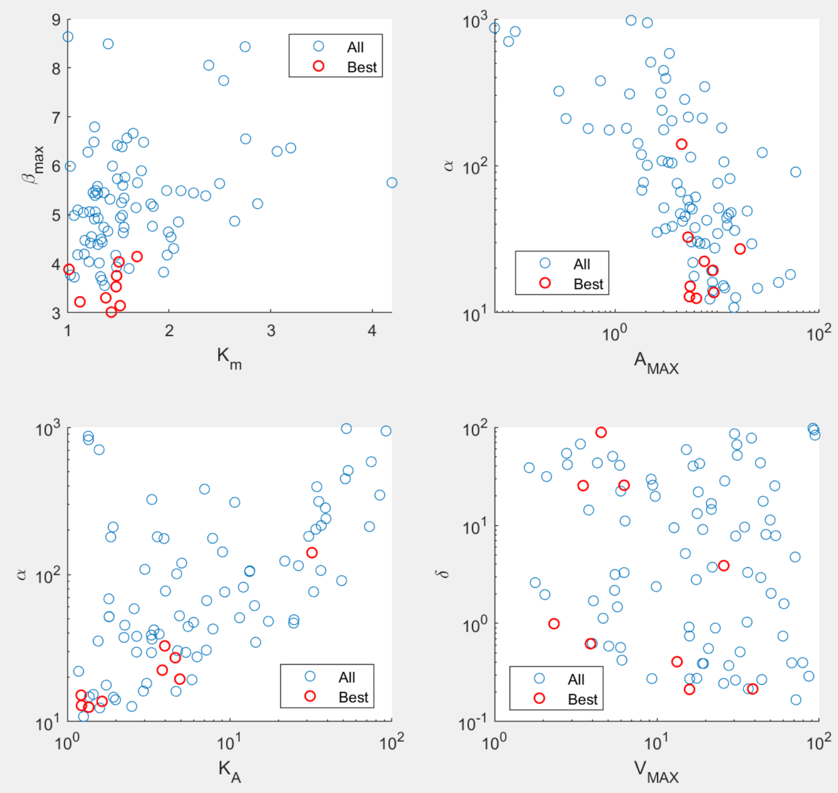

Blue: all 100 sets from optimization. Red: 10 sets with lowest max(Ptot).

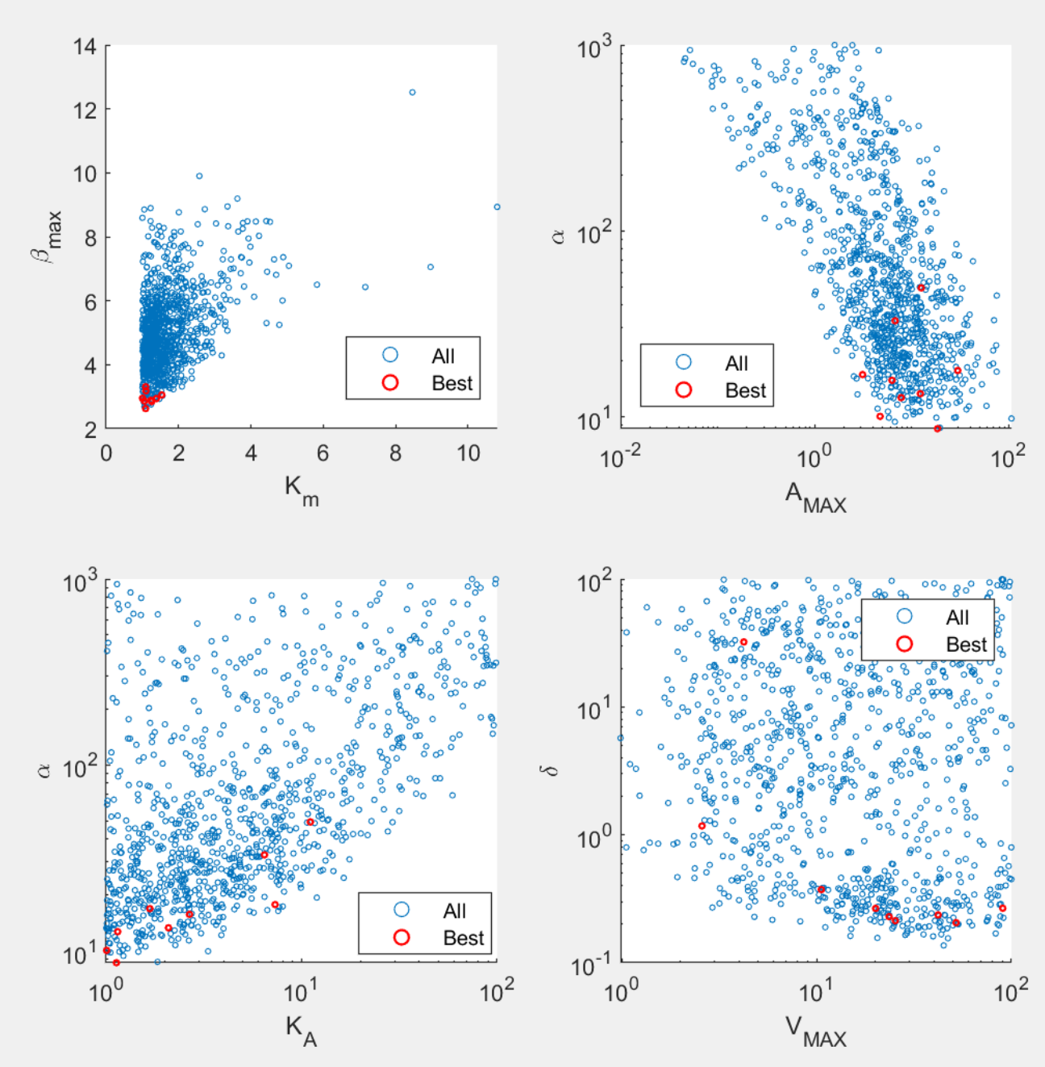

Blue: all 1085 sets from optimization. Red: 10 sets with lowest max(Ptot).

Main patterns:

1. Lower Km and beta_max are preferred. The range is similar to SNF, with beta_max slightly larger.
2. Alpha and AMAX are negatively correlated. Range of alpha is similar to SNF, but range of AMAX is lower than range of AT in SNF.
3. KA positively correlated with alpha.
4. Delta and Vmax are very flexible.
5. Period strongly correlated with beta_max (figure below). This is not surprising, as beta_max determines the time delay.

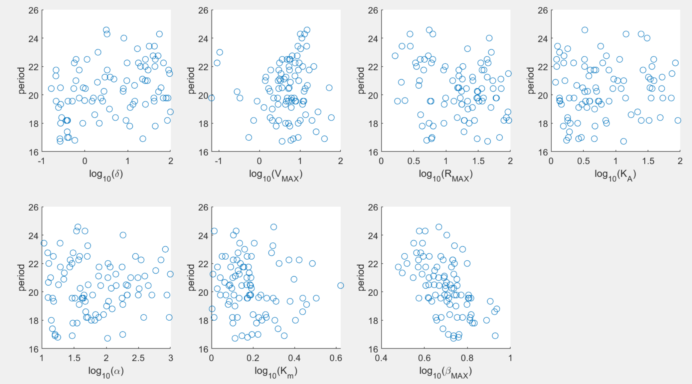100 runs

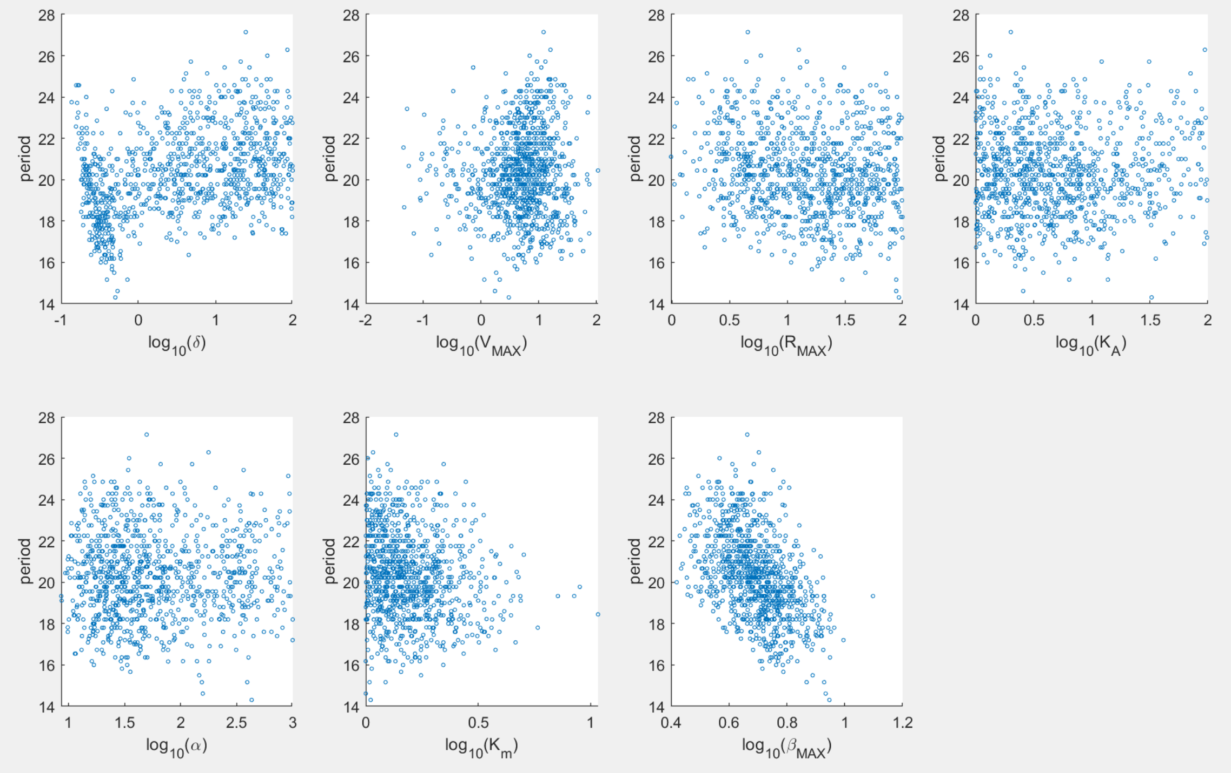1085 runs

# PNF

**Task:** Optimize all 8 parameters: {delta, Amax, Rmax, Ka, alpha, Km, beta_max, eps*}

* eps is the parameter that prevents zeros to be the steady state.

$$\frac{dA_{T}}{dt}=δ\left(A_{MAX}\frac{ε+R}{1+R}-A_{T}\right)$$

**Criteria:**

1. Relative amp of Ptot > 0.25

2. max(Ptot) is minimized s.t Kd is maximized

~~3. BMAL (At) average level matches SNF model~~

4. Relative amp of BMAL > 0.2

~~5. Period of Ptot matches SNF~~

6. max(Ror) < 5

**Method**: simulated annealing with fmincon for the final step; Options: {'TemperatureFcn','temperatureboltz', 'AnnealingFcn','annealingboltz'}

**Cost function:**

**Range of search:**

**Initial guesses:**

100 random samples with Latin hypercube in the range above for the logarithm values of the parameters.

**Results:**

**100 runs:**

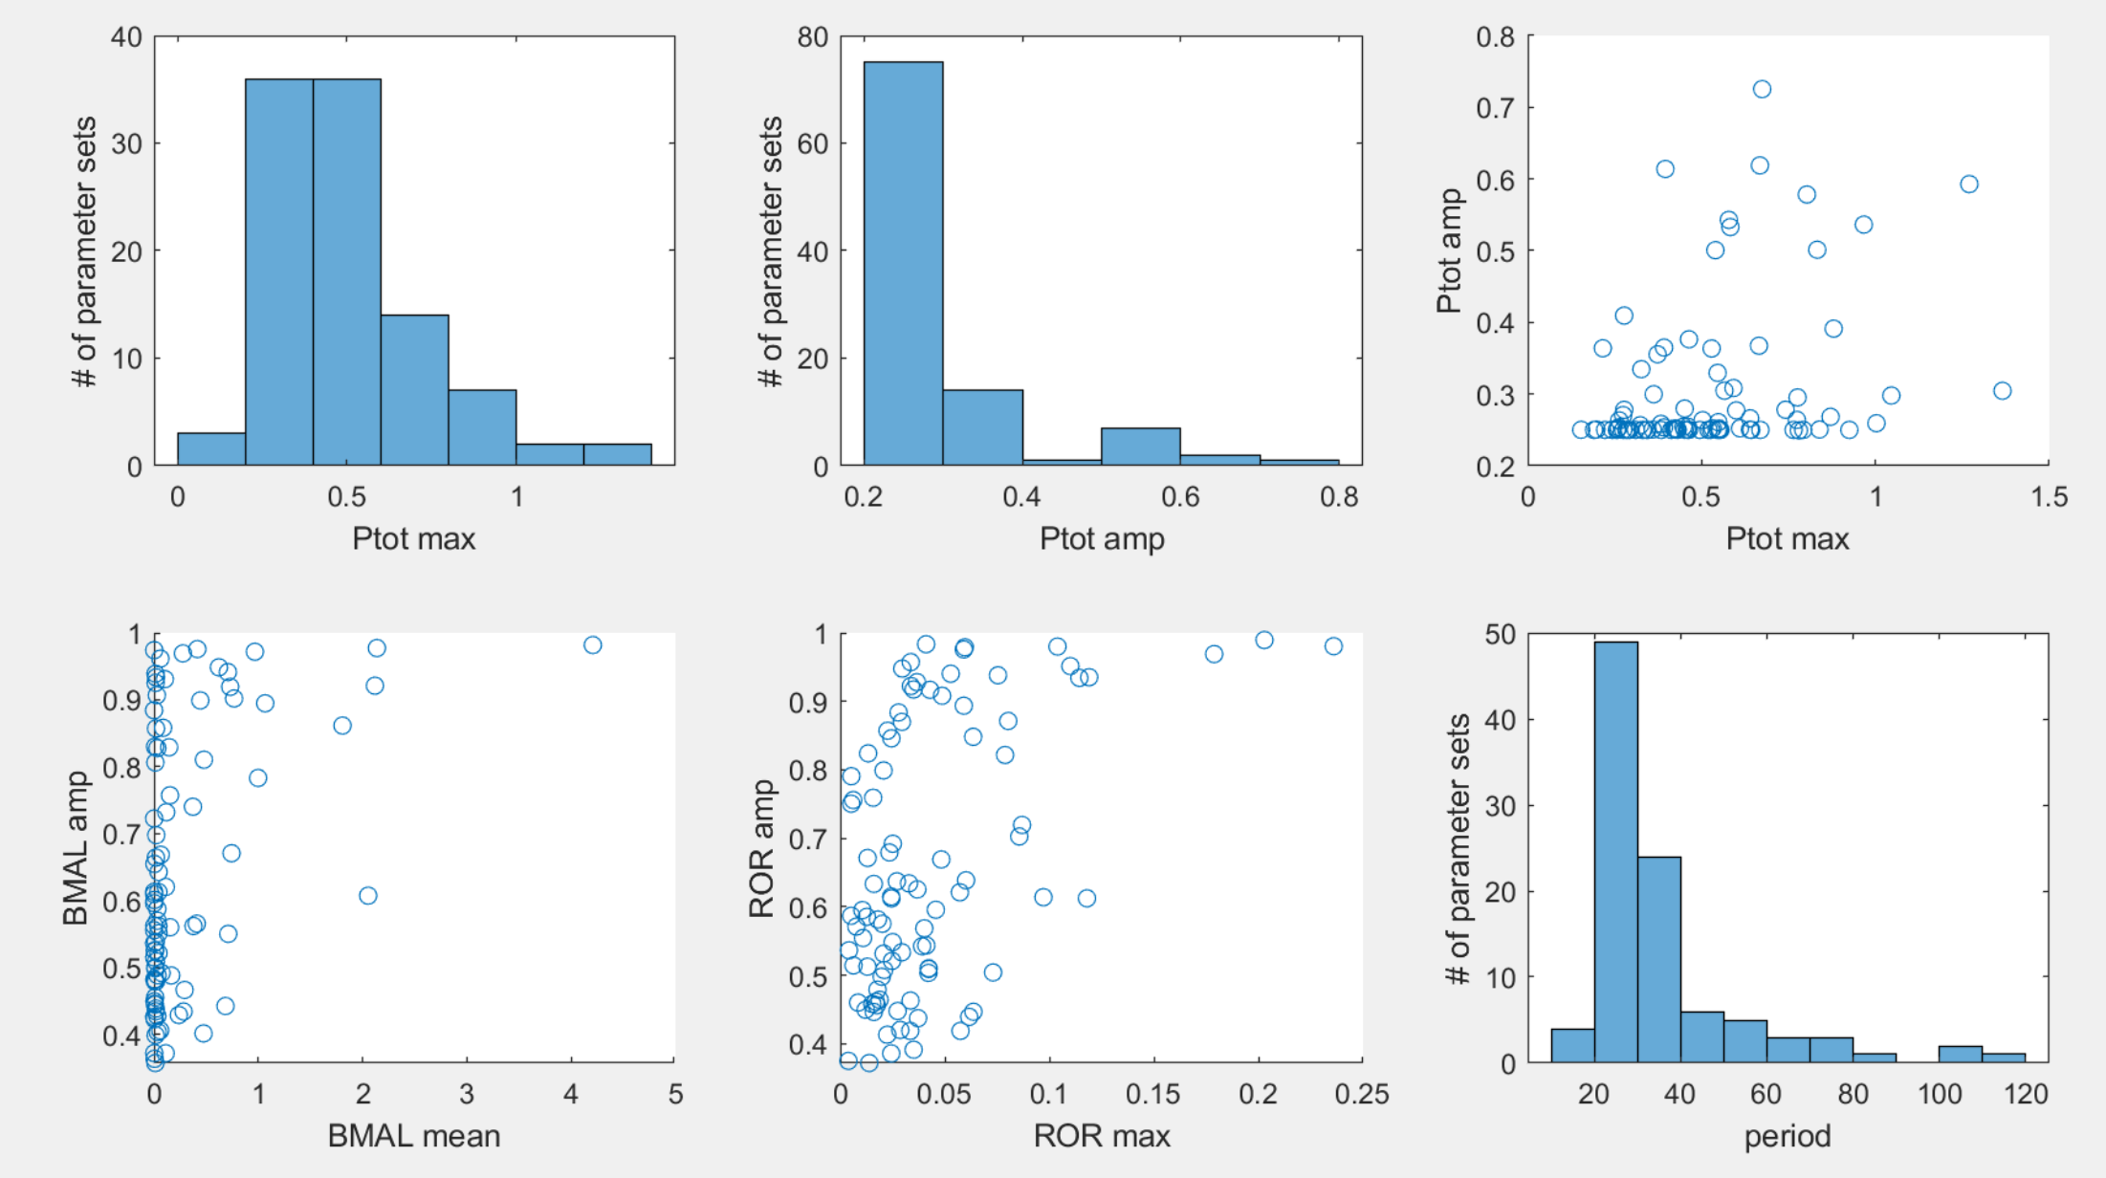

**1092 runs:**

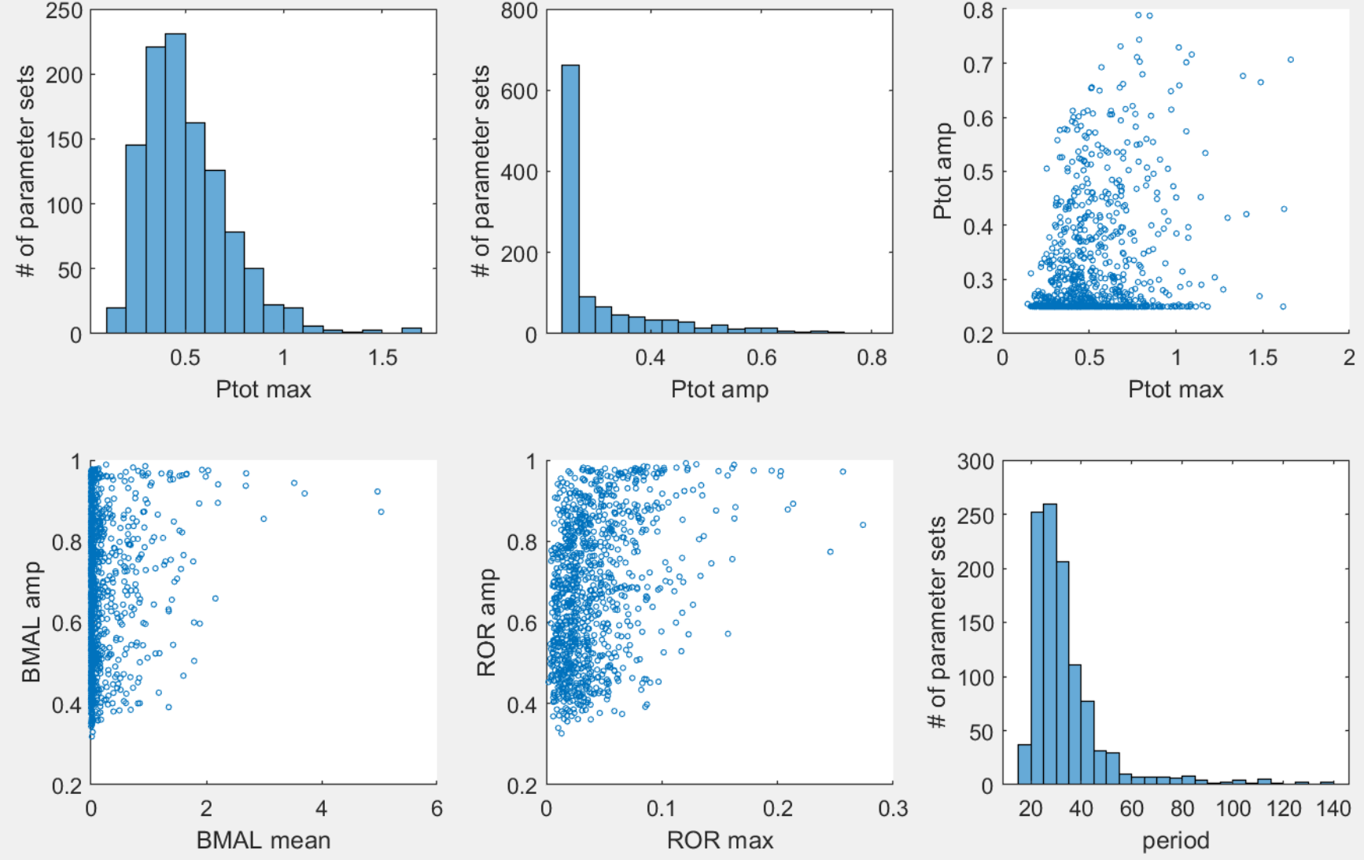

PNF definitely lowers Ptot_max, and hence increases dimensional Kd!

**Best set (with lowest max(Ptot))**

**Out of 100 runs:**

[delta, Amax, Rmax, Ka, alpha, Km, beta_max, eps] = [55.1037 0.8578 41.1534 33.6073 41.3788 39.2248 10.0477 0.0001];

period_sim: 22.8571

Ptot_max_sim: 0.1536

Ptot_amp_sim: 0.2501

BMAL_avg_sim: 0.0109

BMAL_amp_sim: 0.4558

ROR_max_sim: 0.0188

ROR_amp_sim: 0.4643

**Out of 1092 runs:**

[delta, Amax, Rmax, Ka, alpha, Km, beta_max, eps] = [58.2530 2.4938 40.3076 94.8492 33.5920 28.7262 3.8950 0.0001];

period_sim: 25.6667

Ptot_max_sim: 0.1449

Ptot_amp_sim: 0.2549

BMAL_avg_sim: 0.0278

BMAL_amp_sim: 0.5777

ROR_max_sim: 0.0178

ROR_amp_sim: 0.5873

**Patterns for the top parameter sets**

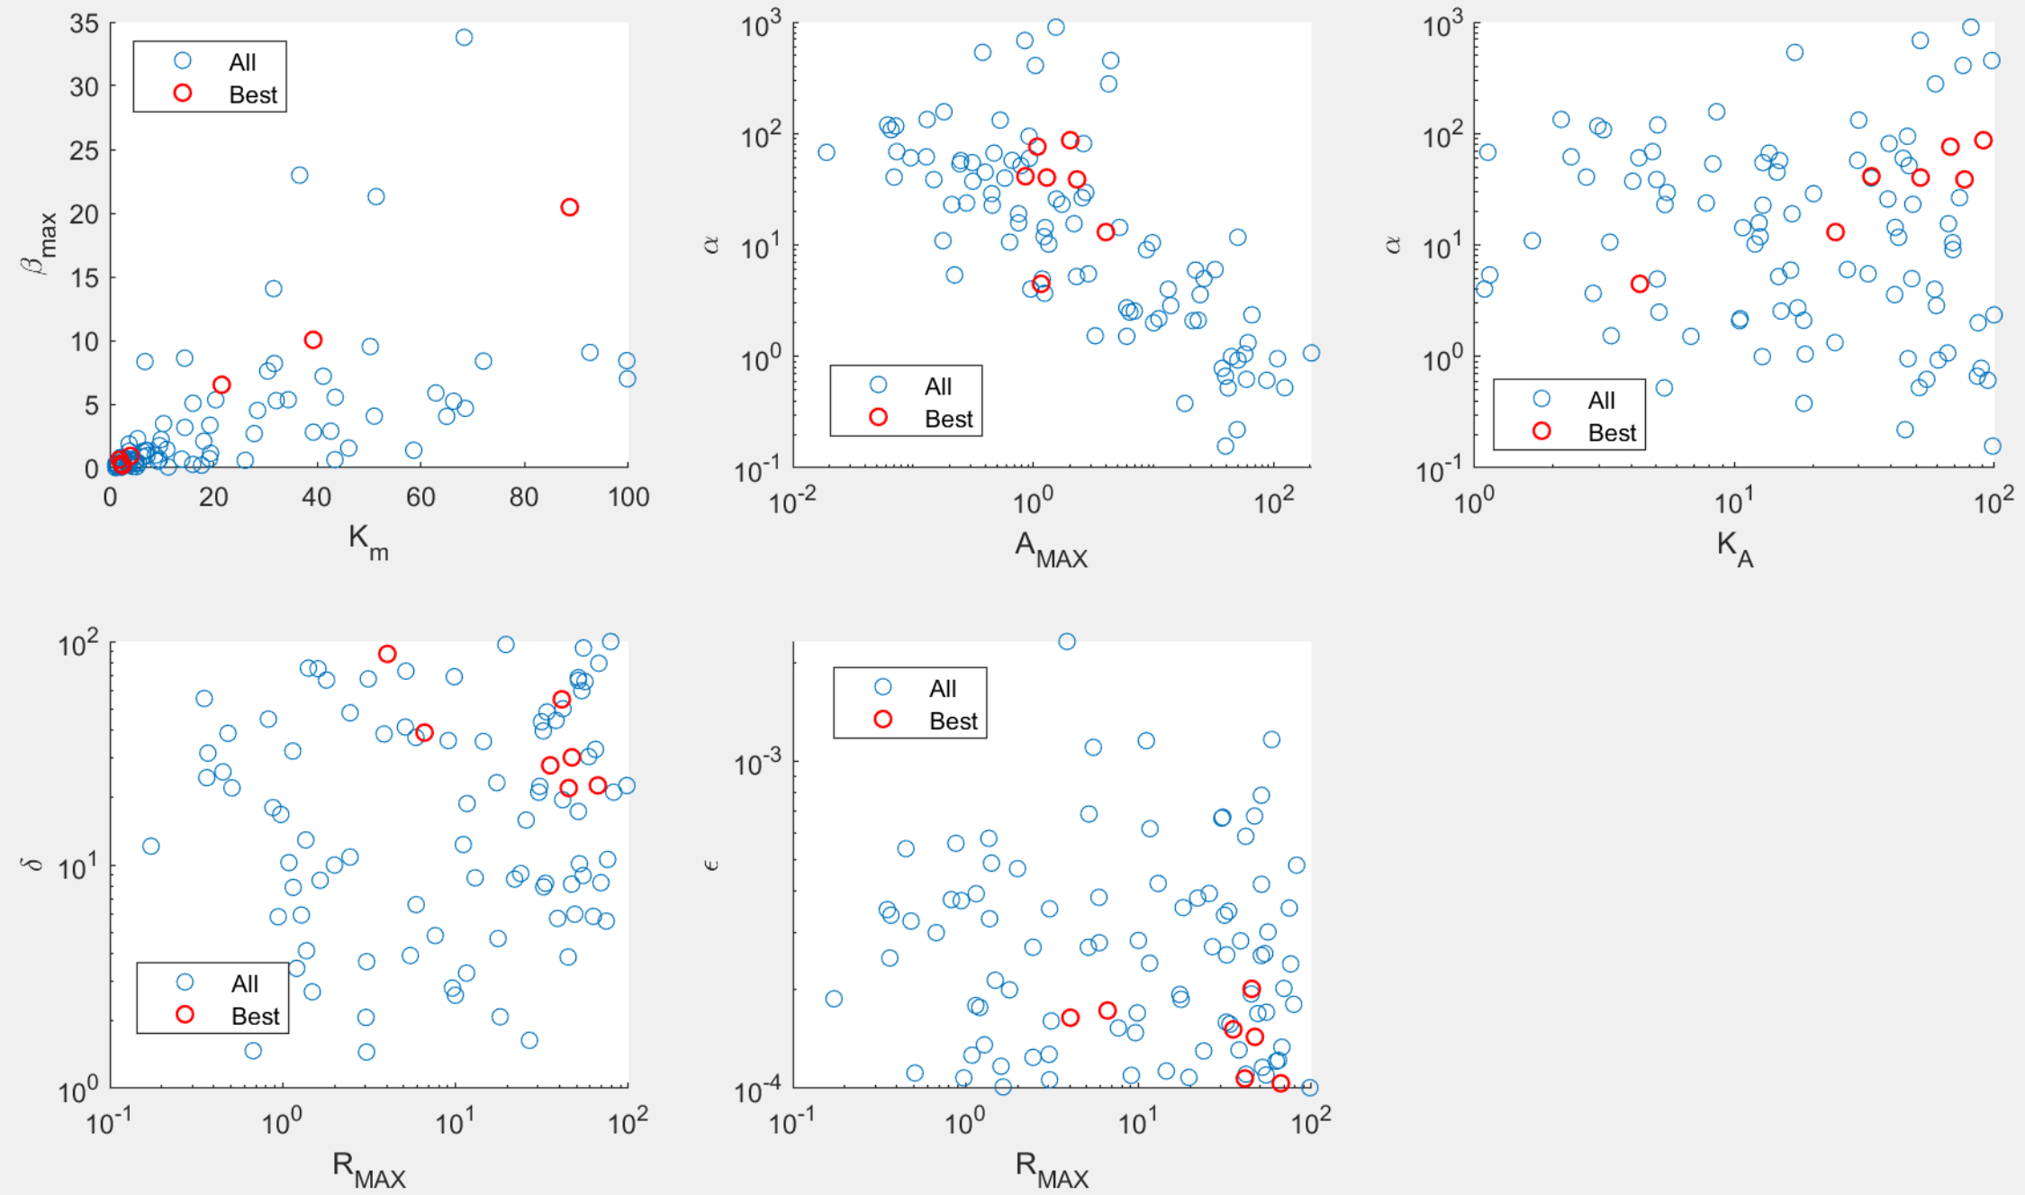Blue: all 100 sets from optimization. Red: 10 sets with lowest max(Ptot).

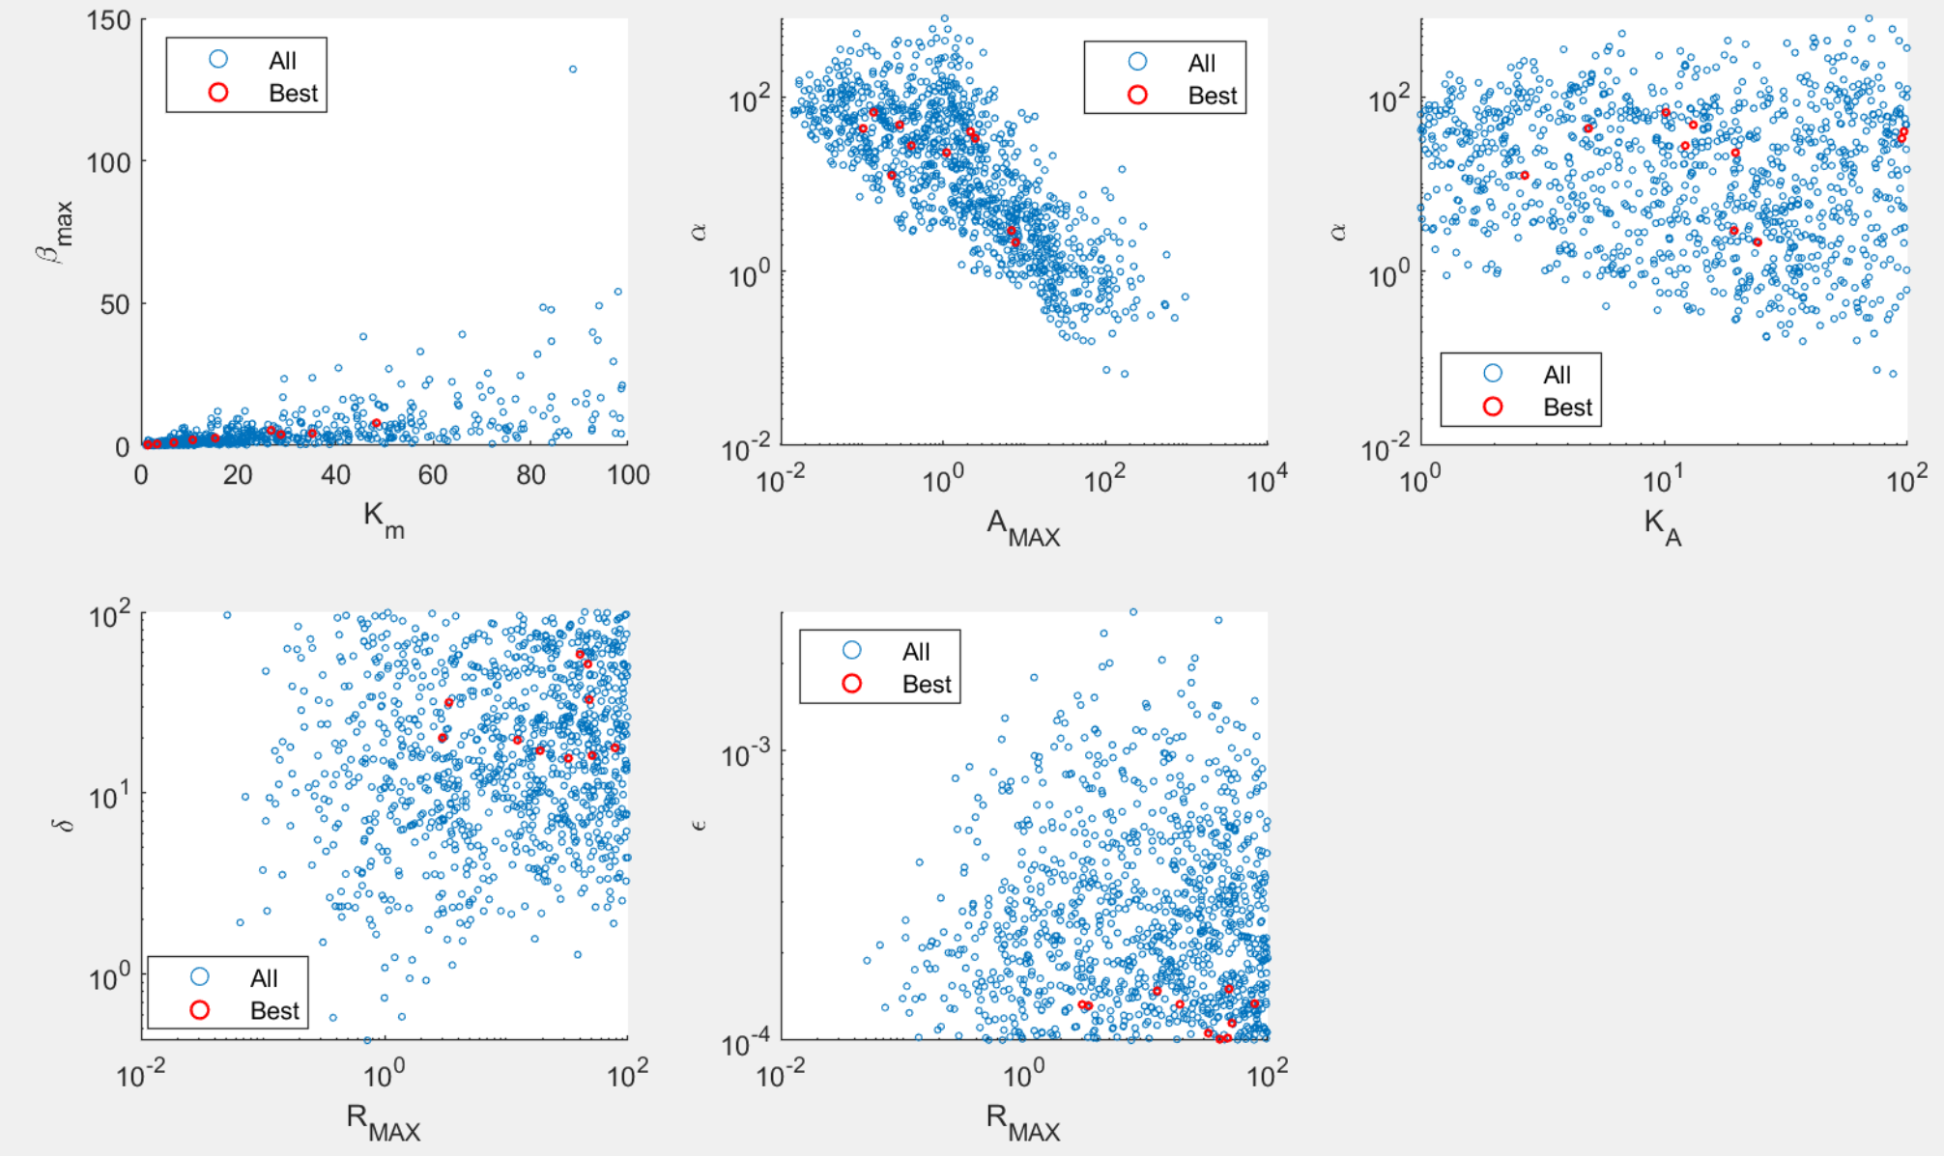

Blue: all 1092 sets from optimization. Red: 10 sets with lowest max(Ptot).

Main patterns:

1. Km and beta_max are restricted to a certain ratio?
2. Alpha and AT are negatively correlated. This pattern is similar to SNF.
3. KA does not seem very restricting.
4. Delta needs to be sufficiently high.
5. Eps needs to be sufficiently low.
6. Period strongly depends on more parameters, including beta_max, delta, Amax, alpha, KA.

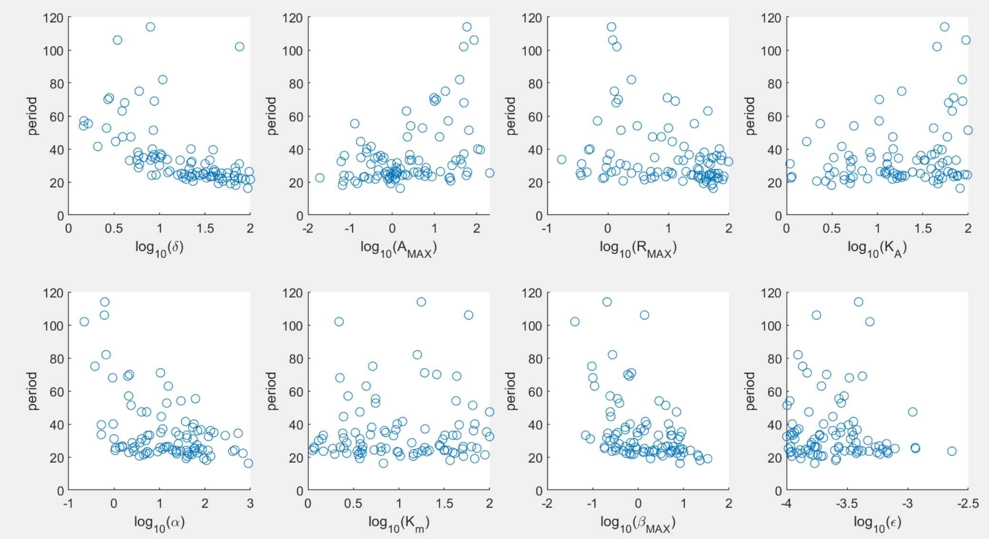

100 runs

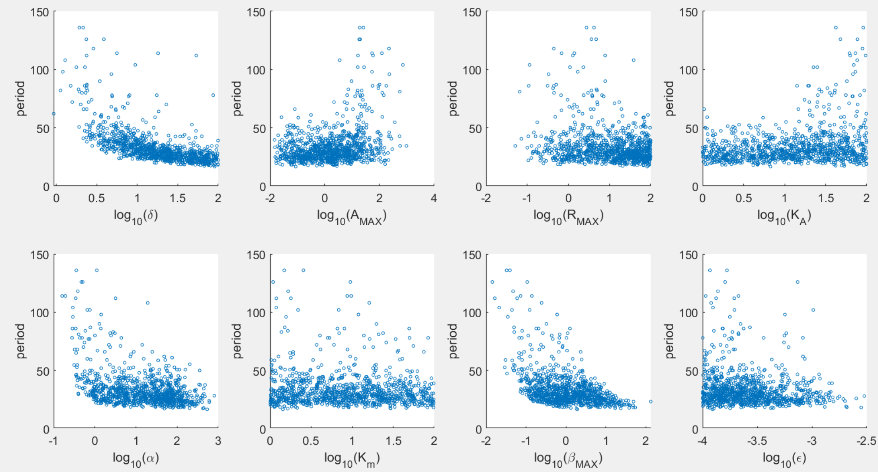

1092 runs